PLACEMENTS

# VIT Bhopal Placement and Training Center

VIT Bhopal ensures the best placements for its students. The university has a centralized placement system for all the campuses through the VIT Career Development Centre similar to the centralized admission procedure followed for all VIT campuses. The VIT Career Development Centre has played a major role in VIT’s illustrious placement record in national and international companies. The Placement training is provided to students right from the first semester to help them in sharpening their coding and aptitude skills. The VIT Alumni Association (VITAA) also supports the placement by providing inputs on the current trends in industry that helps in developing required expertise for better employability.

VIT Bhopal has a dedicated Placement and Training (PAT) cell which coordinates with centralized VIT Career Development Centre and gives training to students for enhancement of their skills and aptitude. It helps the students to prepare for placement interviews in technical and HR aspects by arranging meetings with professional trainers and VIT alumni. It also ensures that the students are well-prepared in group discussions.

## Highlights of VIT Bhopal Placement Centre

* Personalized attention to every student.
* Guidance to the students on their career paths from the first year itself and molding them.
* Passionate webinars by Industry members and Alumni on various topics.
* Attention to detail and molding training based on students’ progress.
* Gamified test and skill enhancement processes.
* Sustained effort so that every student achieves their goals. • Responsive CDC team.

## Salient highlights of 2023 Batch of VIT Bhopal students:-

* More than 1200 offers
* Highest Package : 59 LPA, other prominent offers: 54 LPA, 32 LPA, 27 LPA, 22 LPA
* More than 55%* students placed with Dream and Super Dream offer • Two students received 5 offers
* 90%* placement record for 3 years in a row
* 80+ students received more than 15 LPA package (*among placement registered students)

**Prominent Companies:** Microsoft, Palo Alto, Intel, Ebay, Amazon, Dell, GE, Texas Instruments, Schneider Electric, DE Shaw & Co, Hitachi, HP, PayPal, Tata Motors, L&T, Dr. Reddy’s, Bosch, Deloitte, Morgan Stanley, Qualcomm, Ashok Leyland, Honda, Ford, Global Analytics, TCS, Cognizant, Accenture, Wipro and Infosys have participated in hiring from VIT.

## Highest package of 2022: 45.03 LPA (Microsoft), Highest package of 2023: 59 LPA (Krypto)

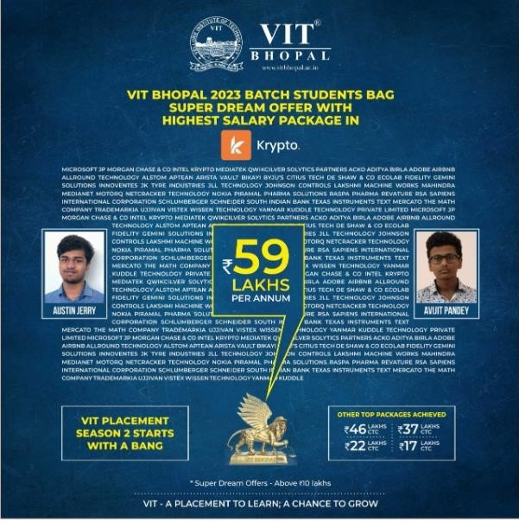

Placement Calendar: Placement Process-Companies

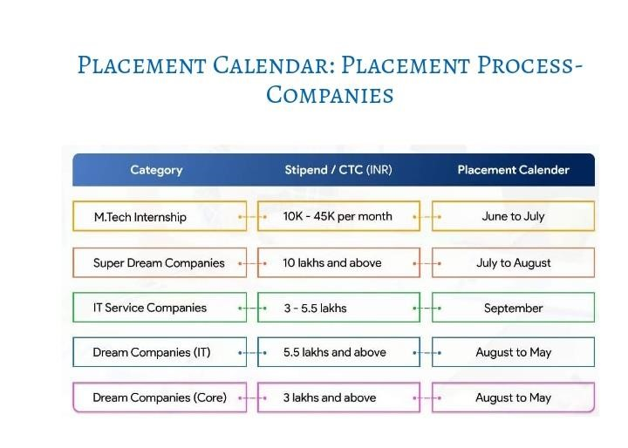

VIT SEES BIGGER OPPORTUNITIES IN BIGGER

## CHALLENGERS

In 2022-23 alone, CDC has brought more than 800 companies on campus for placements with overall 14157 offers. VIT Bhopal has achieved highest package of 59 LPA (Krypto) with 4 students got more than 50 LPA.

**VIT achieves the highest number of dream offers, with attractive salaries, in the country.**

**The following are the major recruiters of Day 1 of 2023 batch.**

### 1.)Abhey Nigam (2017-2021 B.Tech) Got placed in NUTANIX

I came to VIT Bhopal with a passion for technology. VIT Bhopal presented me with so many great opportunities and collaboration centri learning that has truly moulded my personality to the next level and enabled me to make my way in this world of cutthroat competition

2.) **Muskan Choubey (2017-2021 B.Tech)** Got placed in Providence Global Center

I am grateful to VIT Bhopal for providing me a lot of wonderful opportunities throughout the years and specially for the placements. THe PAT team helped with mock interviews, daily aptitude tests and coding rounds as well so that we can be prepared for everything that comes our way